**BSPS AREA 3A WINTER SHOW**

**Friday 17th February 2023**

**Northallerton Equestrian Centre DL7 0PQ**

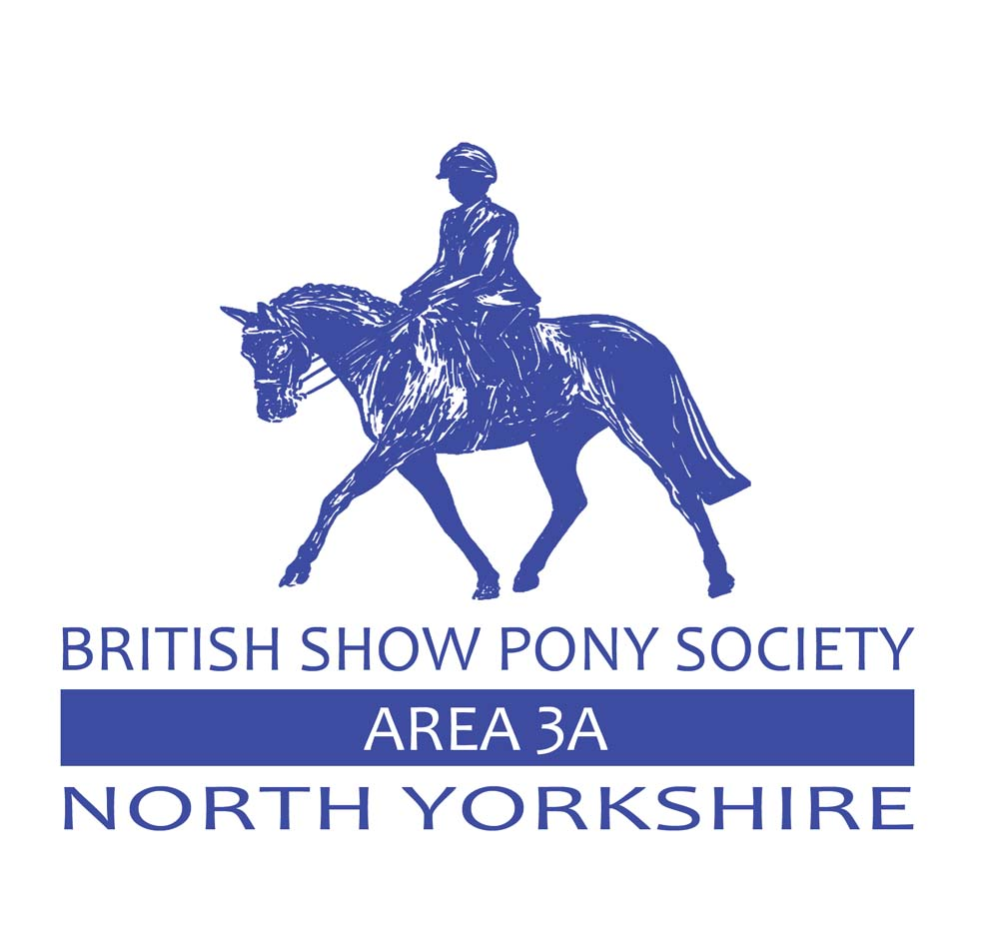

**YOU DO NOT HAVE TO BE A MEMBER OF THE BSPS TO COMPETE AT THIS SHOW**

**### PLEASE NOTE NEW RULES FOR 2023 ####**

Body Protectors **MUST** be worn when jumping in any WHP classes and, also when working in (practice jumps) and the jumping phase in all B.S.P.S. organised and affiliated events.

**All types of Air Jackets are not allowed**.

**HATS**

Correctly secured Skull Caps/Riding Hats Nos. PAS 015 1998 or 2011 with BSI Kitemark, VG1

with BSI Kitemark, ASTM F1163 04a onwards with the SEI mark, SNELL E2001 onwards with

the official Snell label and number, AS/NZS 3838 2006 onwards. MUST be worn by riders at

all times when mounted.  Hats should have a plain cover either Black, Navy Blue, Brown, Grey

or Green.  Velvet covers are encouraged. The B.S.P.S. encourages members to have their hats

tagged through the B.S.P.S. scheme or via the Pony Club Scheme.

**Hat Tagging in B.S.P.S. classes is compulsory.**

(**We are accepting British Eventing, British Riding Club and Pony Club tags)**

**Judge - Clare McCullagh 9.30 Start**

Class 1 **Tiny Tots Lead Rein -** Mare or gelding, 4 years old and over. Ponies must be a Suitable size for rider. Rider to have attained their 3rd birthday but not to have attained their 8th birthday before January 1st in the current year. Maximum height and spread of fences 30cms. Open to plaited and unplaited ponies. Lead rein to be attached to the noseband.

Class 2 **Tiny Tots Starter Stakes -** Mare or gelding, 4 years old and over. Ponies must be a Suitable size for rider. Rider not to have attained their 9th birthday before January 1st in the current year. Maximum height and spread of fences 35cms. Open to plaited and unplaited ponies.

Class 3 **Cradle Stakes** **-** Mare or gelding, 4 years old and over. Ponies not exceeding 122cms. Suitable to be ridden by a rider not to have attained their 10th birthday before January 1st in the current year. Maximum height and spread of fences 45cms. Open to plaited and unplaited ponies.

**WINTER WORKER STAKES (For plaited and Heritage animals)**

**Judge – Clare McCullagh**

Class 4 **60cm Winter Worker Stakes -** Plaited or Heritage Mountain and Moorland Ponies 4yrs old and over not exceeding 158cms. Riders any age but must be suitably mounted for the pony/horse they ride. A Special Rosette for the highest placed child under 12yrs of age on 1st January 2023 in each class who will also qualify for the B.S.P.S. Winter Championships

Class 5 **70cm Winter Worker Stakes -** Plaited or Heritage Mountain and Moorland ponies, 4yrs old and over not exceeding 158cms. Riders any age but must be suitably mounted for the pony/horse they ride. A Special Rosette for the highest placed child under 14yrs of age on 1st January 2023 in each class who will also qualify for the B.S.P.S. Winter Championships.

Class 6 **80cm Winter Worker Stakes -** Plaited or Heritage Mountain and Moorland ponies, 4yrs old and over not exceeding 158cms. Riders any age but must be suitably mounted for the pony/horse they ride. A Special Rosette for the highest placed child under 18yrs of age on 1st January 2023 in each class who will also qualify for the B.S.P.S. Winter Championships.

Class 7 **90cm Winter Worker Stakes -** Plaited or Heritage Mountain and Moorland ponies, 4yrs old and over not exceeding 158cms. Riders any age but must be suitably mounted for the pony/horse they ride. A Special Rosette for the highest placed child under 18yrs of age on1st January 2023 in each class who will also qualify for the B.S.P.S. Winter Championships.

Class 8 **100cm Winter Worker Stakes -** Plaited or Heritage Mountain and Moorland ponies, 4yrs old and over not exceeding 158cms. Riders any age but must be suitably mounted for the pony/horse they ride. A Special Rosette for the highest placed child under 25yrs of age on 1st January 2023 in each class who will also qualify for the B.S.P.S. Winter Championships.

**N.B.** Ponies may compete in more than one height section. Rider should be appropriate age on the day of the Show. The highest placed 3 ponies will qualify for the B.S.P.S. Winter Championships together with the highest placed junior rider

**WHP CHAMPIONSHIP**- 1st and 2nd placed competitors from class 4-8

**Indoor Ring**

**Judge – Craig Elenor**

Class 9BSPS Heritage Mountain and Moorland Novice Lead Rein. Registered pure bred Dartmoor, Exmoor, Shetland, Welsh A or B not exceeding 122cms, four years old and over. Riders not to have attained their 9th birthday before January 1st in the current year.

Class 10BSPS Heritage Mountain and Moorland Novice First Ridden. Registered pure bred Dartmoor, Exmoor, Shetland, Welsh A or B not exceeding 128cms, four years old and over. Riders not to have attained their 12th birthday before January 1st in the current year.

Class 11 BSPS Heritage Mountain and Moorland Restricted/Open Lead Rein Registered pure bred Dartmoor, Exmoor, Shetland, Welsh A or B not exceeding 122cms, four years old and over. Riders not to have attained their 9th birthday before January 1st in the current year.

Class 12 BSPS Heritage Mountain and Moorland Restricted/Open First Ridden Registered pure-bred Dartmoor, Exmoor, Shetland, Welsh A or B not exceeding 128cms, four years old and over. Riders not to have attained their 12th birthday before January 1st in the current year.

**Mini Championship** – 1st and 2nd placed competitors from classes 9-12

Class 13 BSPS Heritage Novice Mountain and Moorland Ridden Small Breeds Registered pure bred Dartmoor, Exmoor, Shetland, Welsh A or B, four years old and over. Riders any age.

Class 14 BSPS Heritage Novice Mountain and Moorland Ridden Large Breeds Registered New Forest, Connemara, Highland, Fell, Dales, Welsh C or D, four years old and over. Riders any age.

**Novice Championship** - 1st and 2nd placed competitors from classes 13 & 14

Class 15 BSPS Heritage Mountain and Moorland Restricted/Open mixed Breeds Registered Dartmoor, Exmoor, Shetland, Welsh A, B, C & D, New Forest, Connemara, Highland, Fell or Dales four years old and over. Riders any age.

**Rules & Regulation**

Neither the BSPS or any of its officers, assistants or stewards shall in any way be responsible for any loss, injury or damages that may happen to exhibitors or their assistants or other members of the public, or to any animal or property or to any vehicle brought into the Showground or on any premises used in conjunction with the Show, or while entering or leaving the same.

It is necessary all exhibitors carry Public Liability Insurance for an adequate indemnity to protect against their negligence including any injury caused by their animals or property.

The organisers reserve the right to cancel or amalgamate any classes if there are insufficient entries.

This show is affiliated to the BSPS (All rules as per the 2023 Rule & Show Handbook) and all persons competing or otherwise taking part are subject to the constitution and rules of the BSPS including disciplinary procedures and shall be deemed to have consented to the jurisdiction of the BSPS.

This show is a qualifier for the BSPS Winter Championships 2023

**ENTRIES ONLINE via the website bspsarea3a.com**

Online pre-entries £12.00 per class

Entries on the day £15.00

Rosettes to 4th place in all classes, except classes 1-3 where all entries will receive a rosette. NO PRIZE MONEY

Show secretaries – Sarah Rudd 0774 0167017 and Jenny Harker 07930 125544

**YOU DO NOT HAVE TO BE A MEMBER OF THE BSPS TO COMPETE AT THIS SHOW**